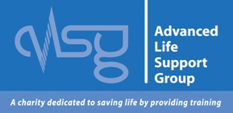

Accommodation close to course venue

We cannot guarantee what any of these are like, we have not stayed in any of them, please book your own choice and take your chance!
However, we have had some past students stay at the Trinity Hotel on Hedon road in Hull, and their comments on their stay were not the best we’ve heard, you may want to give this place a miss.

If you have a good experience at your chosen venue, please let us know, then we can let future students know.

Click on the name of the hotel to go to their website.

The Mayfair Hotel

Doubletree by Hilton

The Royal Hotel (keep an eye on this one, often has good deals)

Inkerman Tavern (closest to venue)

The Carlton Hotel

The Albert Hotel & Sports Bar

Loud Mouth Count Hotel

The Gilson Hotel

Travelodge Hull Central

The IBIS Hull City Centre

Hotel Campanile, Hull City Centre

Holiday Inn, city centre Hull

Premier Inn, Hull City Centre

Premier Inn, Hull West

The Vale Hotel (this is cheap, but the area’s not great, has a kitchen though)

Hideout Hotel (apartments)

Various others

There are obviously others around, you can pick and choose what level of comfort and price you need by using Trivago, Booking.com and Lastminute.com etc.

All except the Premier Inn, Hull West are within a 5-10 minute drive of the venue, the post code of the training venue is HU3 4 DL and is called The Louis Pearlman Centre and is on Goulton Street, off Hessle Road.

